# Error: - 8|78880015| Cmpnt XXXXXX cannot be outed , Cmpnt ct is less than Zero

### Prerequisite:

**Frequency: -** Approx.150 tickets per Month.

**Reference Ticket:** - 000000256729690

**IOM Order** [194721508]

**Dependency:** - GIOM and CADM

**Efforts spends:** - 10 to 15 mins per order.

**Links Required:-**

BVOIP Order Status Tool:

<http://giom.cif.att.com:9001/servlet/ToolsServlet>

SAM Tool:- <http://euam.ims.att.com:8010/EUAM/InitialSAMGateway?jadeAction=INITIAL_SEARCH_ACROSS_BILLER_ACTION_HANDLER>

DB Detail:-

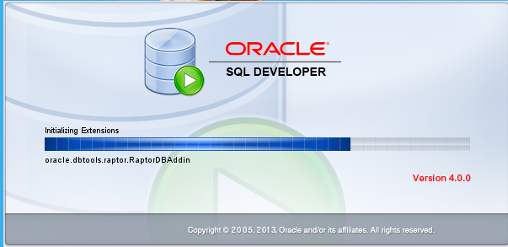

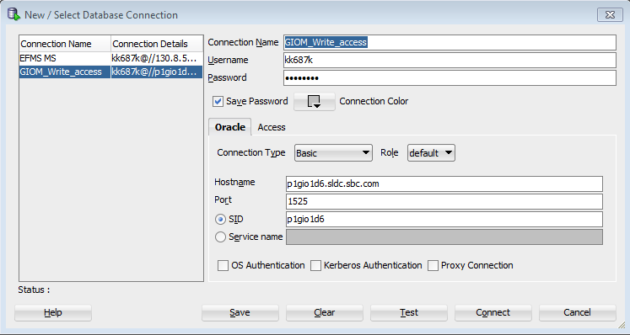

Hostname: p1gio1d6.sldc.sbc.com

Port: 1525

SID: p1gio1d6

# WorkAround :-

## Step 1:- Check error through GIOM DB using below script:

select io.order_name, so.DATETIME_UPDATED, so.supplier_status, so.ERROR_CODE, so.ERROR_MSG from iomdbo.supplier_order so, iomdbo.iom_order io

where io.iom_order_id = so.iom_order_id

and io.order_name = '194721508'

and transaction_name in (71);

where supplier_status 1 = Failure

supplier_status 0 = Success

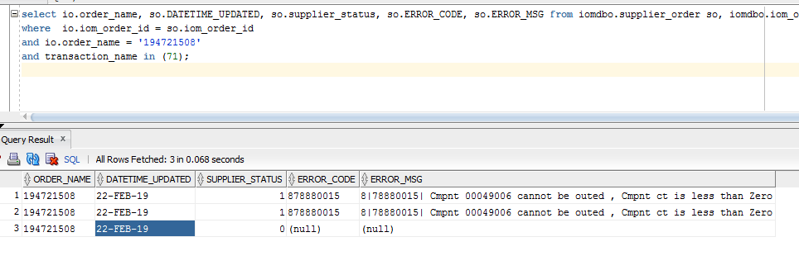

## 1.1 (optional) check error message in BVOIP Order Status Tool:-

Put order in BVOIP order tool.

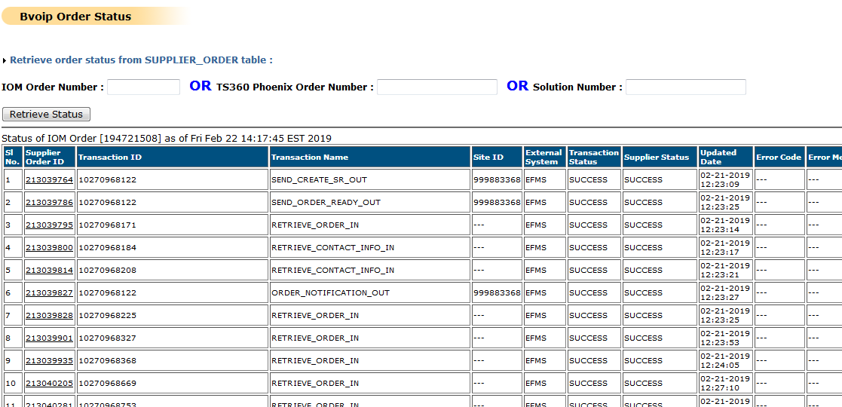

check the error corresponding to BSE and copy the component from error message.

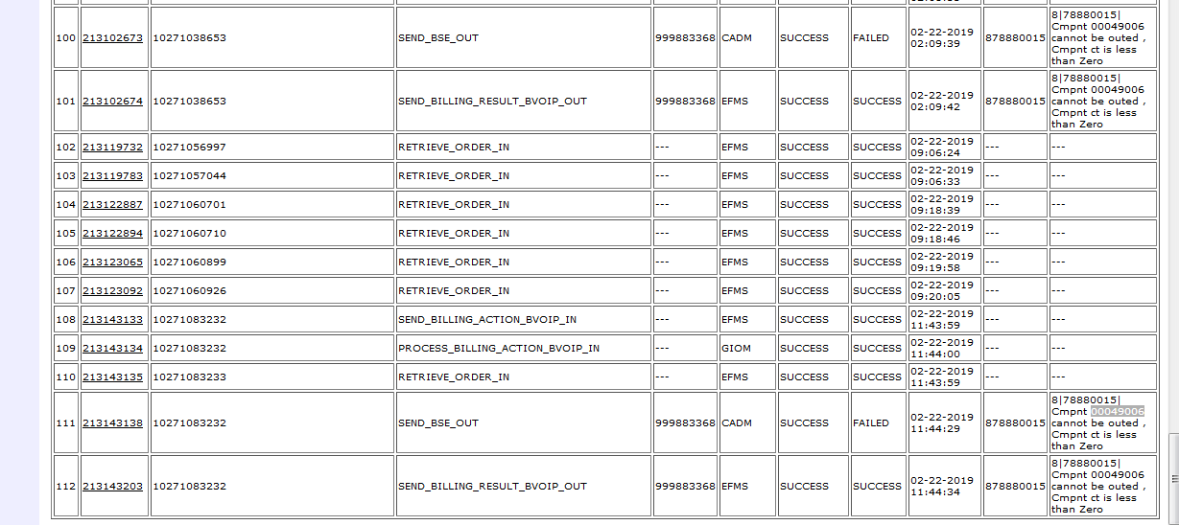

Note:- Optional BVOIP Order status Tool steps Ended

## Step1.2:- (optional) Error can also be checked through EFMS GUI:- select order/Suborder

After selecting Type:- Suborder and pasting order number in ID: 194721508. Click on ‘Find’ button.

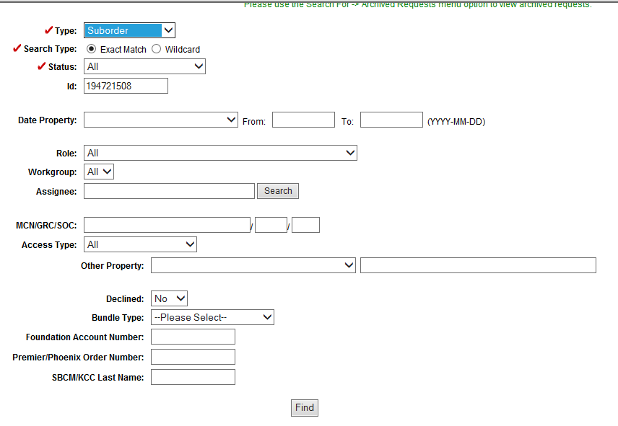

On Next screen click on Open Button.

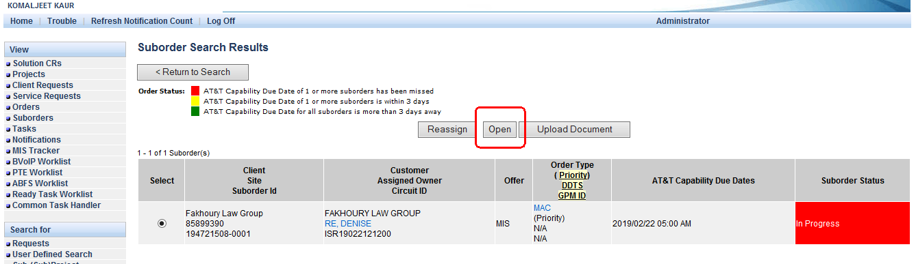

Then select Suborder Details

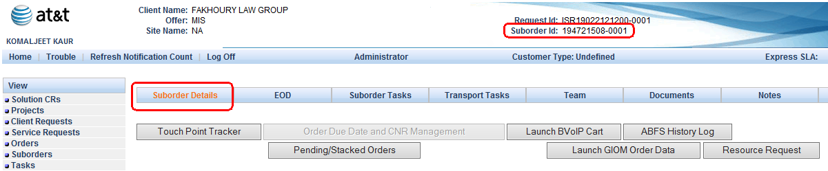

Select radio button corresponding to Giom Tier Error and click on Open Task.

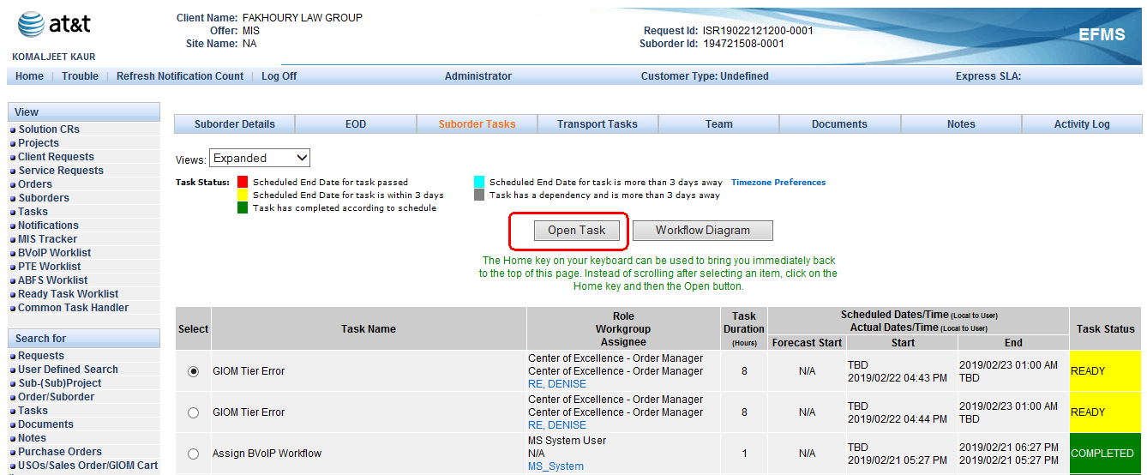

Then click on Activity Log

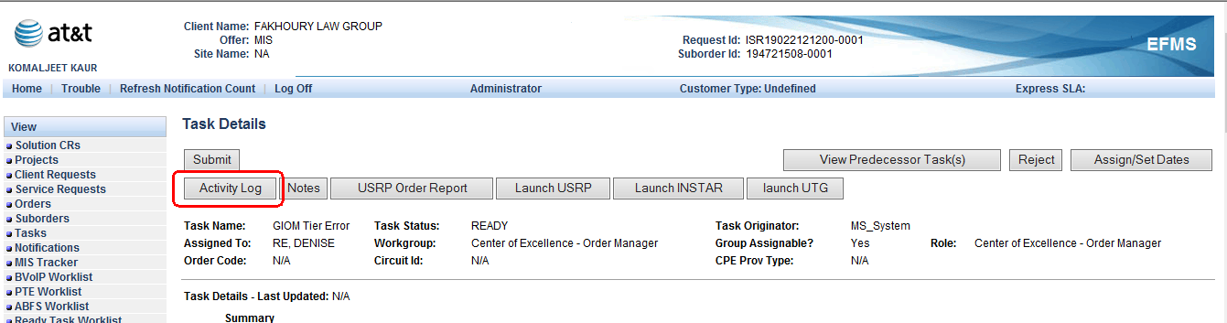

Check the error message corresponding to Date and time.



Note:- Note:- Optional EFMS steps Ended.

## Step 2:- Use below script in GIOM DB to get PPC corresponding to component '00049006'

select

prod_pkg_code

from iomdbo.sa_trans_fdb where svc_comp_id='00049006';

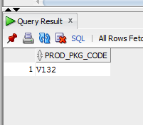

## Step 3:- Use the below script to get complete info corresponding to order regarding component.

select o.order_name, ac.acty_multiple_id, bc.billing_comp_id "From B ID", bc2.billing_comp_id "TO B ID", bc.prod_pkg_code ppc, bc.qnty "Qnty_From", bc2.qnty "Qnty_To",-- bc.valid_ind BCVAL, ac.valid_ind AMVal,

f.feature_name, s.svc_comp_id, s.phpc

from iomdbo.BILLING_COMP bc, iomdbo.BILLING_COMP bc2, iomdbo.iom_order o, iomdbo.sa_trans_fdb s, iomdbo.FEATURE2PRODUCT f, iomdbo.acty_multiple ac, iomdbo.activity a

where bc.iom_order_id=o.iom_order_id

and bc.valid_ind='Y' and ac.valid_ind='Y'

and bc.prod_pkg_code=s.prod_pkg_code

and bc.prod_pkg_code=f.prod_pkg_code

and ac.activity_id=a.activity_id

and a.iom_order_id=o.iom_order_id

and ac.change_comp=58

and ac.comp_id=bc.billing_comp_id

And Ac.To_Comp_Id=Bc2.Billing_Comp_Id

And O.Order_Name In ('194721508')

Union

select o.order_name, ac.acty_multiple_id, bc.billing_comp_id "From B ID", null "TO B ID", bc.prod_pkg_code ppc, bc.qnty "Qnty_From", null "Qnty_To",-- bc.valid_ind, ac.valid_ind,

f.feature_name, s.svc_comp_id, s.phpc

from iomdbo.BILLING_COMP bc, iomdbo.iom_order o, iomdbo.sa_trans_fdb s, iomdbo.FEATURE2PRODUCT f

, iomdbo.acty_multiple ac, iomdbo.activity a

where bc.iom_order_id=o.iom_order_id

and bc.valid_ind='Y' and ac.valid_ind='Y'

and bc.prod_pkg_code=s.prod_pkg_code

and bc.prod_pkg_code=f.prod_pkg_code

and ac.activity_id=a.activity_id

and a.iom_order_id=o.iom_order_id

and ac.change_comp=58

And Ac.Comp_Id=Bc.Billing_Comp_Id

And Ac.To_Comp_Id Is Null

And O.Order_Name In ('194721508')

Union

select o.order_name, ac.acty_multiple_id, null "From B ID", bc.billing_comp_id "TO B ID",bc.prod_pkg_code , null "Qnty_From", bc.qnty "Qnty_To",-- bc.valid_ind, ac.valid_ind,

f.feature_name, s.svc_comp_id, s.phpc

from iomdbo.BILLING_COMP bc, iomdbo.iom_order o, iomdbo.sa_trans_fdb s, iomdbo.FEATURE2PRODUCT f

, iomdbo.acty_multiple ac, iomdbo.activity a

where bc.iom_order_id=o.iom_order_id

and bc.valid_ind='Y' and ac.valid_ind='Y'

and bc.prod_pkg_code=s.prod_pkg_code

and bc.prod_pkg_code=f.prod_pkg_code

and ac.activity_id=a.activity_id

and a.iom_order_id=o.iom_order_id

and ac.change_comp=58

And Ac.To_Comp_Id=Bc.Billing_Comp_Id

And Ac.Comp_Id Is Null

And O.Order_Name In ('194721508')

;

After running the above script check the From B ID and To B ID from the output.

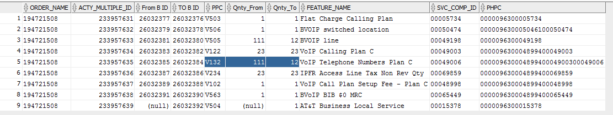

## Step4:- Open router in SAM to compare component

How to fetch charge number/ Router.

1. Click on supplier id corresponding to BSE

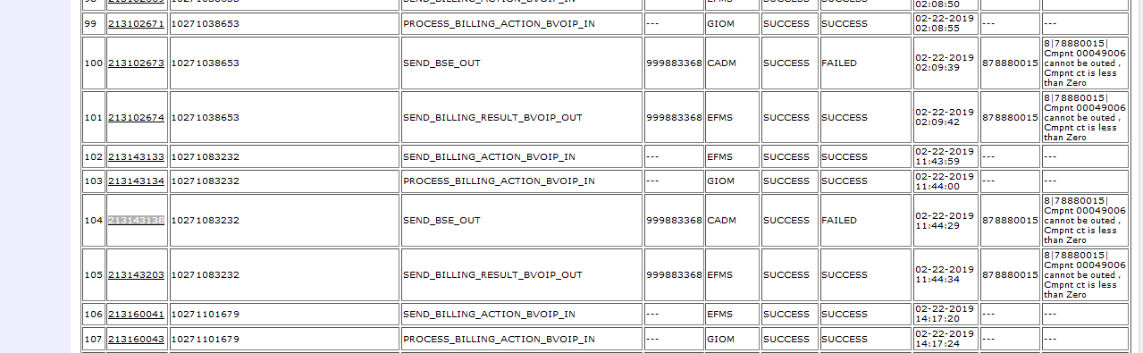

1. On Next page search router with keyword “charge_number”

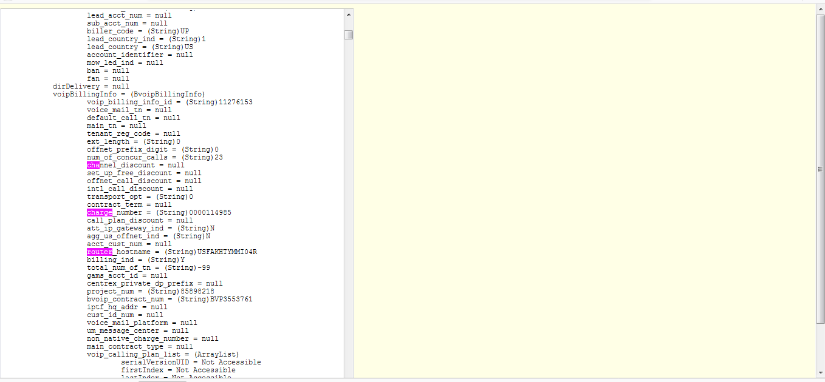

Router:- charge_number = (String)0000114985

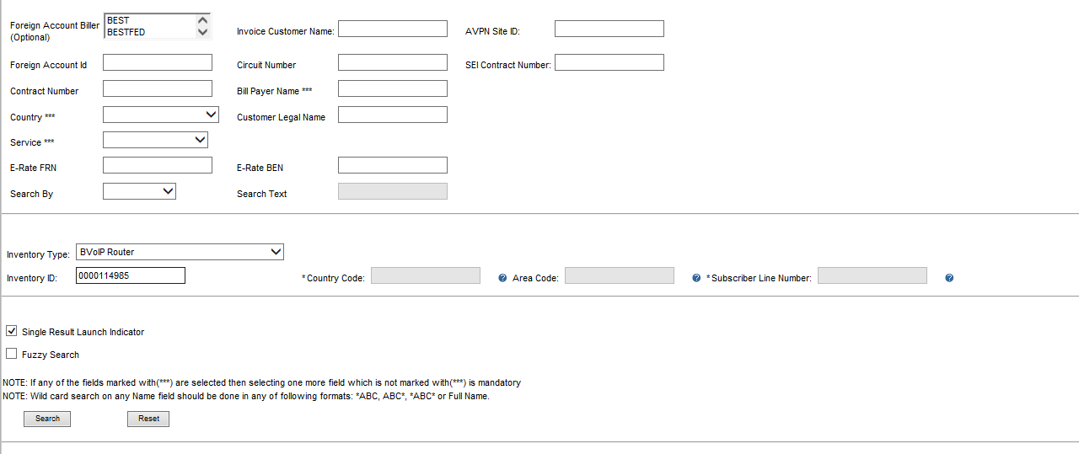

## Step 5:- Expand the Sub Account and select the router

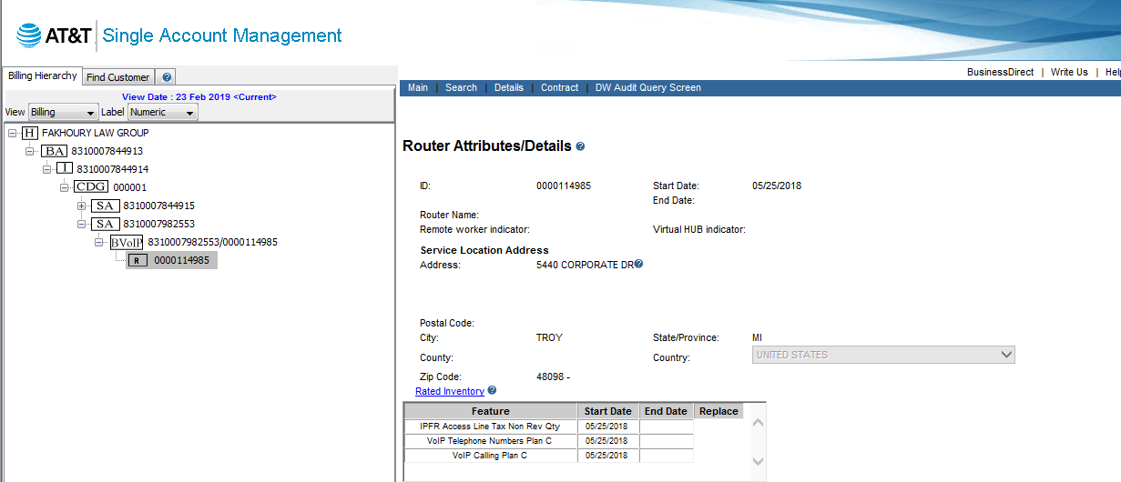

## Step 6:- click on [Rated Inventory](http://euam.ims.att.com:8010/EUAM/EUAMGateway?jadeAction=VIEW_ROUTER_ATTRIBUTES_DETAILS_ACTION_HANDLER&EUAM_SELECTED_NODE_HP_ID_VIEW_KEY=1036185&EUAM_SELECTED_NODE_TYPE_VIEW_KEY=NI&EUAM_CUSTOMER_NODE_ID_VIEW_KEY=41486904&EUAM_CUSTOMER_MKT_SEGMENT_CODE_KEY=0007&EUAM_SEARCH_DATE_VIEW_KEY=null&EUAM_CUST_BILLING_HIERARCHY_ID_VIEW_KEY=42183652&EUAM_SELECTED_VIEW_TYPE_VIEW_KEY=Billing&EUAM_HNODE_COUNTRY_VIEW_KEY=US&EUAM_SELECTED_ROUTER_ID_VIEW_KEY=1036185&EUAM_SELECTED_PARENT_NODE_TYPE_VIEW_KEY=NI&EUAM_SELECTED_NODE_PARENTHPID_VIEW_KEY=226789463&EUAM_SELECTED_NODE_ID_VIEW_KEY=0000114985) [Quick Help](javascript:uitmpl_qh('RATE');)

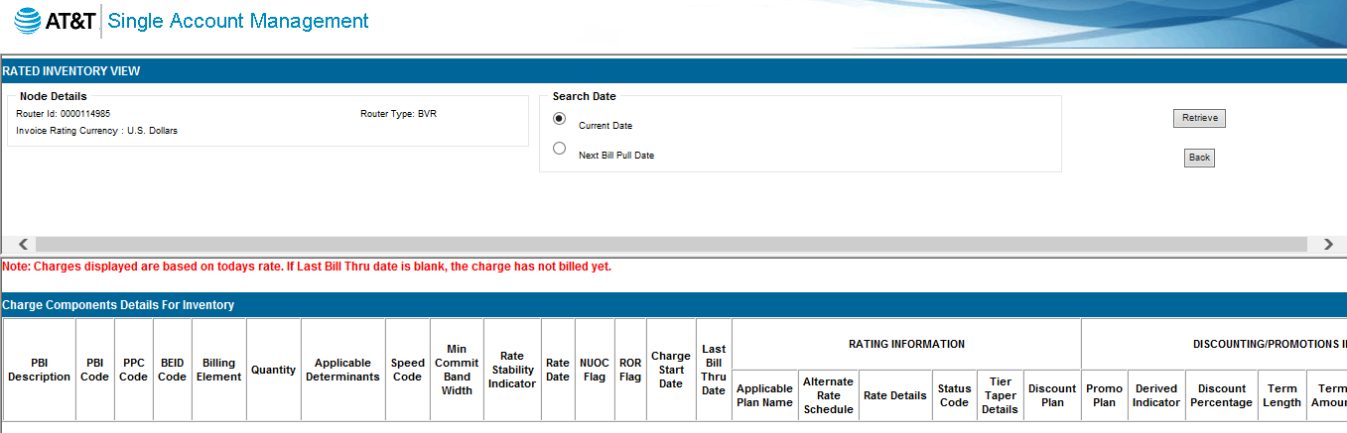

## Step 7 :- click on Retrieve you will get below screen.

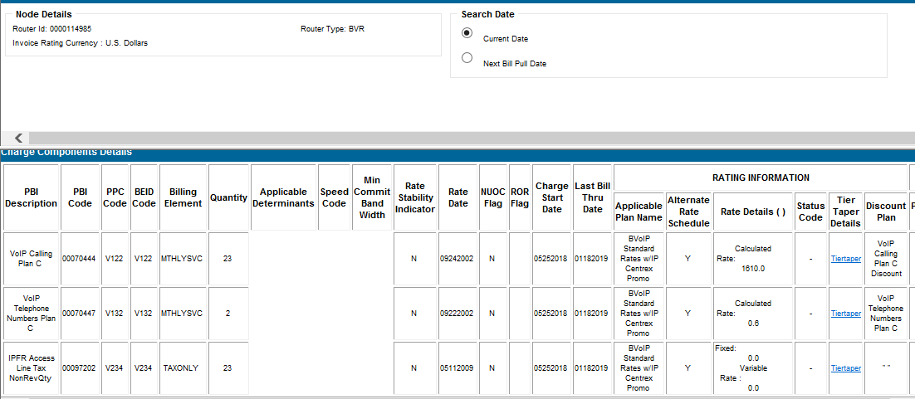

## Step 8:- compare both Quantity. In this case Quantity corresponding to component V132 in SAM is 2 and in GIOM DB from Quantity is 111.

## Step 9:- In BSE sheet update below fields

Col. A:- Order_Name:- same as USH.

Col. B (Effective_bill_date) use the below script in EFMS DB

Effective_bill_date :- 20171221000000(YYYYMMDDHHMMSS)

select billing_effective_date from ms_order where usrp_order_number in ('194623145');

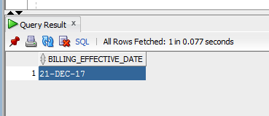

Col C:- PPC code Corresponding to component.

Col D:- quantity 109 i.e 111-2= 109(From_Qnty – Qnty from SAM)

Col E:- I/O as per the difference in Qnty which we are getting from Col D (negative or positive)

Col F:- N(always same)

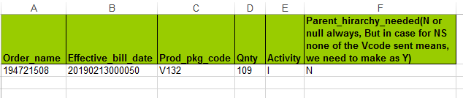



## Step 10:- Upload above sheet in CADM Simulator using below credential (always same)

User name: - cadm

Password: - cadmgiom

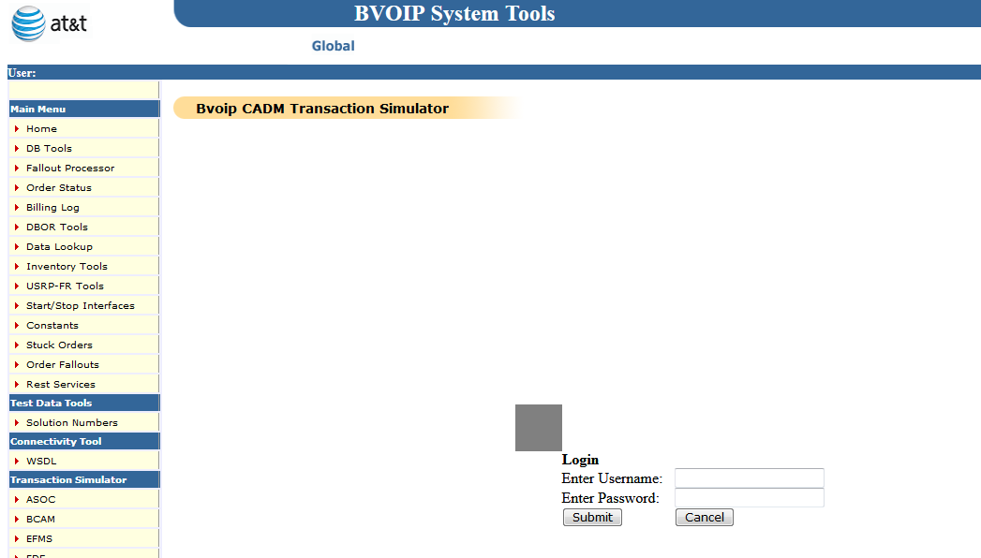

## Step 11:- select the BSE from Drop Down and add order in comment after that upload the BSE sheet.

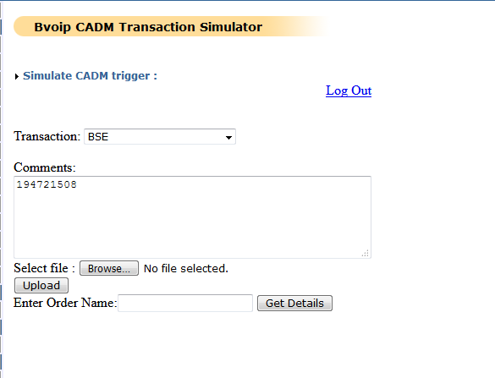

## Step 12:- Once Transaction is successful then Force Complete the GIOM Tier Error task using below step.

### Force Complete the GIOM Tier Error task

If there are multiple GTEs, all of the GTEs need to be force completed.

1. cd /opt/app/home/prodsupp/complete  
  
 2. fc.run (script name)

Please refer below M&P for FC



*Reference to Mnp where task are skipped and fcd*

**Note - Once task is force completed, it can’t be undone.**

#### 

## Step 13:- Wait for 20 mins for billing transaction to flow.

## Verify if billing is success or not using below query:

## The latest transaction should be success with supplier_status = 0.

select io.order_name, so.DATETIME_UPDATED, so.supplier_status, so.ERROR_CODE, so.ERROR_MSG from iomdbo.supplier_order so, iomdbo.iom_order io

where io.iom_order_id = so.iom_order_id

and io.order_name = '194721508'

and transaction_name in (71)

order by datetime_updated desc;

where supplier_status 1 = Failure

supplier_status 0 = Success

## Step 14:- Need to re-validate from BVOIP for success or failure for error. If it is a success go to Step5.

Check below transaction if they are successful

SEND_BSE_OUT

SEND_RSC_OUT

SEND_BTF_OUT

PROCESS_BTN_REQUEST

SEND_BTN_OUT

PROCESS_BTN_RESPONSE

SEND_BILLING_RESULT_BVOIP_OUT

In case of failure and same error_code is same then start from step2, else mark it as RED in USH/AOTS.

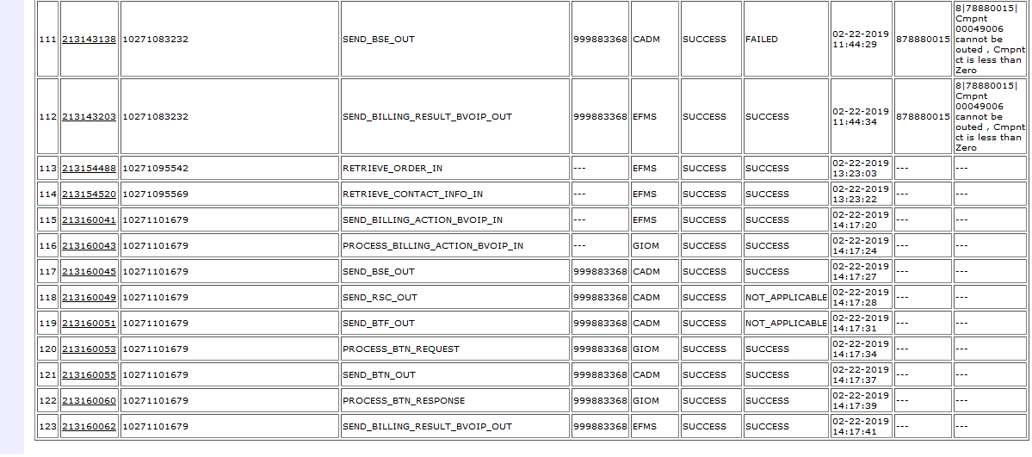

ISSUE RESOLVED.